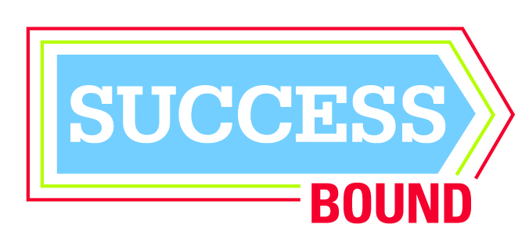

SuccessBound Health March 1 Preliminary Agenda

8 a.m.—8:30 a.m.
Registration

8:30 a.m. –8:40 a.m.
Welcome & Introductions

8:40 a.m. - 9:00 a.m.
Kick-Off- Why Are We Here?
Dr. Barbara Tobias, Medical Director, The Health Collaborative and Interim Chairperson, Family & Community Medicine, University of Cincinnati College of Medicine

9 a.m.—9:45 a.m.
Recruiting and Engaging Interest in Health Careers
Panel – Feedback
Facilitator: Sharron DiMario, Center Director, Area Health Education Center, University of Cincinnati College of Medicine, moderator
- TriHealth Pathway Exploration Program
Jeremiah Kirkland, Executive Director for Women’s Services, TriHealth
- UC College of Nursing Pathway Program- HEALTH Pathways Programming
- Bon Secour Mercy Health Explorers
- TAP-MD, TAP-Healthcare
Heleena McKinney, Director of Workforce Education, The Health Collaborative

9:45 a.m. – 10:30 a.m.
Guided Discussion Using Feedback Technology
Facilitator: Donna Lauver, Community Partnership Specialist, Forest Hills School District

10:30 a.m. –11:15 a.m.
Innovative Pathways to Healthcare Employment
Facilitator: Hope Arthur
- Pre-Apprenticeships and Apprenticeships
Hope Arthur, Director, Health Careers Collaborative, Partners for a Competitive Workforce; Erin Heinrich, Career Tech Compliance and Curriculum Manager, Cincinnati Public Schools
- Clermont Chamber of Commerce Foundation Work Readiness Initiative
Susan McHugh, Director, Clermont County Chamber of Commerce
- Work Readiness Seal – Ohio Means Jobs
Kayla Mickens, Career Connections Consultant, Ohio Department of Education

11:15- Noon
Guided Discussion: (Using Feedback Technology)

Noon—12:30 p.m.
Lunch and Resource Fair: Register for Industry Tours

12:30 p.m. –1:15 p.m.
Health Care Professions- Emerging Employment Trends

1:15 p.m. – 3:00 p.m.
Next Steps – Working Together to Expand Opportunity

