Brain Injury Awareness Walkathon 2018

On Saturday June 16, 2018 Brain Injury Drop-In members, FVBIA members, friends and families will be walking and wheeling around the track at Mill Lake Park to raise awareness and funds for special events for the drop-in and for FVBIA.

Walker’s name

Check all programs you are raising money for:

Abbotsford Brain Injury Drop-In
Chilliwack Brain Injury Drop-In
(Cheques Payable to Communitas Supportive Care Society)

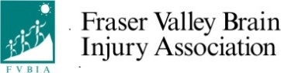
Fraser Valley Brain Injury Association
(Cheques Payable to Fraser Valley Brain Injury Association)

Name | Address | $ | Cash | Cheque
Sample George Jones | 123 Abbotsford St , Abbotsford ,BC V2T 2L1 | 5 | X
Name | Address | $ | Cash | Cheque

Donations over $10 that are accompanied by a FULL Name and complete mailing address will receive a Tax receipt.

