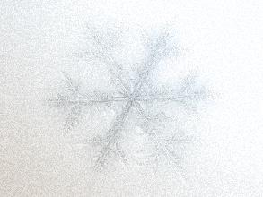
Winter is coming
AGENDA
April 17, 2018

07:30 Registration

08:00 Continental Breakfast

08:30 Welcome & Opening Remarks
Dr. Neil Parry: Medical Director
LHSC Trauma Program

08:40 Regional Trauma: The Cold Hard Facts
Summary of Regional Trauma Data

09:00 The Cold and Icy Crash
MLEMS: Adam Bennett
OPP: Constable Emad Haidar

9:30 Impact: Bad Decisions Don’t Always Make Good Stories
Hilary Dagg, Trauma Survivor

10:00 When Blood Runs Cold
Dr. Kelly Vogt: Associate Medical Director
Physician LHSC

10:30 Break/Exhibit Viewing

11:00 Are Their Ears Burning? Are We Leaving Our Patients Out in The Cold?
Dr. Brenda Berge, Au.D.

11:30 Trillium Gift of Life: Hypothermic Effects
On Organ Donation
Dr. Ian Ball, LHSC Physician

12:00 BCVI
Amy Makish, NP LHSC Trauma Program

12:30 Lunch/Exhibit Viewing

13:30 Warming Up To the Trauma Family
Bev Lewis, SW and Danielle Kilby, RN
Critical Care Trauma Centre, LHSC

14:00 Royal College Rumble
Dilaudid: The Painful Dilemma
Dr. TJ Leeper. LHSC Physician vs. Dr. Luke Hartford

14:30 Break/Exhibit Viewing

15:00 Keynote Speakers: 27 Minutes Submerged
Ashlyn and Braeden Krell, Trauma Survivors

16:00 Closing Remarks & Evaluation
Dr. Neil Parry

