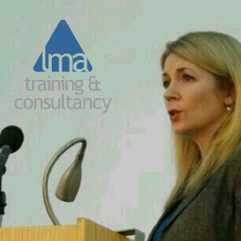
Lysa Morrison is the Managing Director of LMA Training & Consultancy. The company is founded on years of combining business and public sector practice with tools and techniques from coaching, neuro-linguistic programming and psychology.
This unique combination has allowed the development of entirely new ways of doing things and thinking that weren't possible before, and create conceptual 'models' of any situation to help our customers understand their situation in new ways and find a way forward.
The result? Consistently client-centred, outcome-focused solutions that seem to work anywhere and everywhere.

Lysa later developed this approach even further, using 'systems-thinking' in her position on the boards of local NHS and community development trusts to bring about lasting and meaningful change for whole organisations and communities. She is currently in the last year of her Executive MBA to add the latest Masters Degree-level business theory to her offering.
In 2007 Lysa founded LMA Training & Consultancy and has grown it from a part-time to full-time business, working with Chief Executives, boards, managers and staff, salespeople, HR professionals, social workers, consumers, patients, service users, vulnerable people and volunteers in every imaginable type of organisation:
- Global, national and local businesses
- National government departments and local authorities
- International standards agencies
- Health, housing and social care providers and commissioners
- NHS trusts and local boards
- Schools, Pupil Referral Units and Children's charities
- Charities, social enterprises, community organisations and volunteer groups
- Art galleries, museums and cultural organisations
- Customer service departments, hospitality, deep-sea engineers, telecare and telehealth suppliers, weight-loss specialists, law firms, software suppliers, recruitment agencies... and more!

