MEET THE 2O2O WOMEN ON BOARDS CHICAGO TEAM

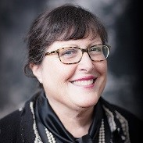
- Kathy Graham (Chair)
Kathy Graham is the Founder/Principal of The HQ Companies, Inc., a group of four firms that are all about human capital for board growth, career growth, and corporate growth. She is a member of the Chicago Finance Exchange, an active leader of the Private Directors Association® (PDA), serving as PDA’s National Chief Marketing Officer. Kathy earned an MBA in Analytic Finance, Econometrics, and Statistics from The University of Chicago Booth School of Business. She serves as a University of Chicago’s Alumni Club of Chicago Board Director, currently Chair of the Engagement Committee for all University colleges, formerly Governance Committee Co-Chair.

- Rebeccca Wing (Co-Chair)
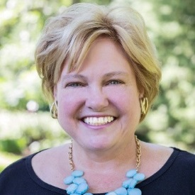
Rebecca Wing is an internationally experienced COO, General Counsel, Financial Services Expert and Private Company Board of Director (Qualified SEC Financial Expert). Her global experience traverses multiple continents and countries to include Europe, Eastern Europe, United Kingdom, Canada, Latin America, China, Australia, Mexico, Middle East, BVI, the Caymans, and the Bahamas. She is known for leveraging strong business acumen, strategic vision, and operations/risk management/legal/compliance knowledge to grow private/public businesses organically and via M&A and for her ability to identify legal issues and their potential impact on business operations, then mitigate those risks while achieving solution driven desired outcomes.

- Hajara Al Amodi (Co-Chair)
Hajara Al Amodi is a global investor, technologist, board director and a businesswoman. She is the chairwoman and CEO of AL Amodi Avenues, a holding company with a presence in North America & Asia. Hajara is a board director, with real estate, e-commerce and tech companies in India, USA and Africa. She sits on the investment committee at ALMPG Group in USA, works with the research committee at 30% Club in the Middle East Region, and represents the NED on Board (Non- executive directors), a private UK organization working on educating/increasing accountability of independent directors. Hajara has joined the board of ALMPG Start up Council, which is the first official Muslim owned startup incubator and is also leading their investment committee as a chair.

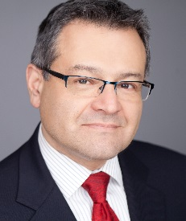
- Lino Carrillo
Lino is the Vice President, Home Delivery for Oberweis Dairy in North Aurora, IL. In his role, Lino brings over 35 years of experience working with consumer products companies ranging from Coca-Cola to the Frito-Lay unit of PepsiCo. During his career, Lino has filled many roles ranging in responsibility from multi-cultural marketing and strategy to sales and executive leadership. His experience includes many years of P&L management, executive leadership, change leadership, new product development and international assignments. Lino holds a Master of Business Administration from Oklahoma Christian University and a Bachelor of Science in Marketing from Bradley University.

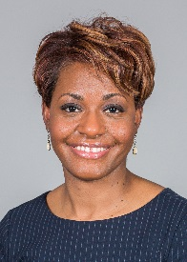
- Jerri Edwards
Jerri Edwards is the Vice President and Senior Credit Officer for New Markets Support Company, where she develops/executes the credit culture for the organization; leading the credit and risk management functions; and establishing the policy for NMSC’s portfolio. Well versed in the CDFI space, her prior roles include Senior Director and Chief Credit Officer at Seaway Bank and Trust Company, and over 9 years in leadership roles with the Lending, Underwriting and Portfolio Management Departments at Urban Partnership Bank. She earned an MBA from the University of Chicago Booth School of Business and Bachelors in Accounting from Florida A&M University.

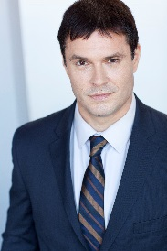
- Andy Feltovich
Andy Feltovich is a Vice President in Global Risk Management at Northern Trust. Prior to joining Northern Trust in 2016, Andy held positions at KPMG, The Federal Reserve Bank of Chicago, TransUnion, and HSBC. He holds a BA in Political Science from Southern Illinois University, a MA in Economics from the University of Illinois, the CFA designation, and passed the CFP™ exam in 2018. In addition to 2020 Women on Boards, he’s an active member of the CFA Society of Chicago, the Executives Club of Chicago, the Chicago Council on Global Affairs, the Private Directors’ Association, and Toastmasters International.

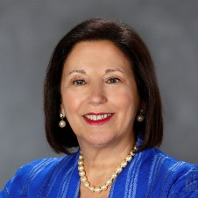
- Mary Ann Hynes
Mary Ann is a global C-suite leader, Board member, and advisor for private/public companies. She earned an MBA from Lake Forest Graduate School of Management, a JD and LLM, Taxation from The John Marshall Law School, and a BA from Loyola University. Prior firms: IMC Global, Inc. and its boards; Sundstrand Corporation where she acquired 11 companies in 15 months; and Wolters Kluwer U.S./CCH, Inc., where she was the first woman in America to become a Fortune 500 GC. Mary Ann’s other boards: Dr. Scholl Foundation—Lead Director/Chair, Audit and formerly GHD Pty, a $1B global engineering/environmental consulting ESOP firm.

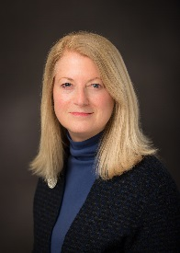
- Martha McGuire
Martha McGuire is an Executive Vice President for First Bank of Highland Park, where she is responsible for a third of the Bank’s loan/lease portfolio and is a member of the Asset Liability Committee and Employee Benefits Advisory Committee. She is a legacy First National Bank of Chicago banker and held senior corporate finance positions with its investment banking subsidiary and its successors. Martha recently served as President for the Chicago Finance Exchange, is a past YWCA of Chicago Board President and a member of the Kellogg Alumni Council. She has an MBA from Kellogg School of Management, Northwestern University.

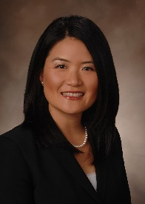
- Kate Seitz
Kate is an assurance partner at RSM US LLP, primarily focused in the financial services sector. She is responsible for serving clients, developing the firm’s financial services audit methodology, and providing consultations and quality reviews for engagement teams. Kate is active in diversity groups. She is the President/board member of the Midwest Chapter of ASCEND, the nation’s largest Pan-Asian business professional organization; the national leader of InspirAsian, RSM’s Asian employee network group, comprised of over 600 members; and a member of the Chicago Finance Exchange. Kate received her BA/MS in Accountancy from University of Illinois-Champaign and is a CPA.

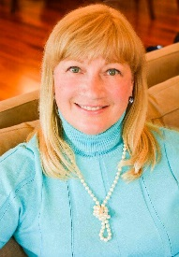
Karen Staib Duffy
Your collaborator for greater success! Karen’s specialty is Developmental and Strategic Coaching, focusing on long-term results. A confidential sounding board, she works with leaders to improve current performance, prepare for promotions, and take on higher levels of responsibility. Karen is adept at working concurrently with multiple layers of leadership within an organization, maintaining confidentiality and trust at all times. Karen is a Professional Certified Coach with the ICF and Ontological Coach through Newfield Network, with a BA from Northwestern University and MBA from the University of Chicago Booth.

- Jim Williams
Jim Williams is a talented graphics designer, indexer, and publisher/editor. For many years, he ran his family’s publications business that offered books teaching doctors and hospitals the basics and best of nutritional care. A long time freelancer, Jim enjoys tackling computer and design challenges and transforming them into practical beautiful solutions in tune with his client’s personas/needs. Jim earned his Master of Arts from Johns Hopkins University’s School of Advanced International Studies and his undergraduate degree from Stanford University in Economics and History.
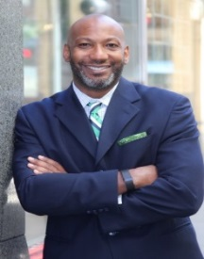
- Vince Williams
Vince Williams is the Director of Membership and Business Development for The Executives Club of Chicago. He was recently named to Diversity MBA magazine’s 2018 Elite List of Top 100 Emerging and Executive Leaders under the age of 50. Vince is also an entrepreneur and serves on several boards around the City. He is currently the Co-Chair for the Board of Directors Leadership Council with Year Up Chicago – a program that addresses the opportunity divide in Chicago. Vince has a BA in Management from Robert Morris University and MBA in Finance from Morris Graduate School of Management.

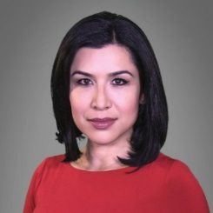
- Jazmin Beltran (Co-Chair, Marketing)
Jazmin Beltran is a bilingual multimedia journalist who has spent more than a decade covering stories in Chicago and the Midwest. She’s been a TV news reporter for Univision Chicago, publisher for Univision.com and adjunct lecturer at the Medill School of Journalism at Northwestern University. Jazmin has also served as lead instructor for Global Girl Media where she taught young women from under-resourced communities digital journalism, creative writing, interviewing skills and video production. Jazmin earned her Bachelors and Masters degrees in Journalism from Northwestern University.

- Rida Iqbal
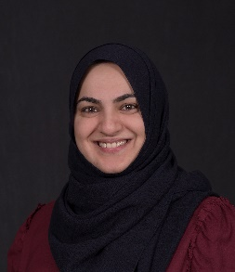
Rida Iqbal is a principal at Traxonomy LLC, a financial advisory start-up that specializes in business solutions leveraging modern technologies like Blockchain, Machine Learning and Artificial Intelligence. Before launching Traxonomy, Rida began her career as part of the Transaction Advisory Team at Ernst & Young specializing in Financial Reporting, M&A, Project Finance, Infrastructure Advisory, Corporate Restructuring Advisory and Transaction Support services. She is a member of Business Valuation Association, ACCA USA and CFA Society Chicago and leads PDDARI efforts in Chicago. Rida holds a BSc. In applied accounting from Oxford Brookes University (UK), Advanced Financial Modeler (AFM) certification from Financial Modeling Institute, ACCA affiliate (UK) and is in the process of obtaining her CFA Charter holder.
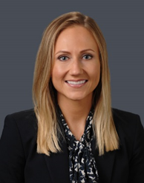
- Jessica Lubczynski
Jessica is a Manager with RSM US LLP’s financial services assurance practice. She oversees investment company and broker dealer audit engagements and provides consultation to hedge funds and broker dealers on industry and entity specific issues. She is also actively involved in development talent at RSM and instructs at firm wide trainings. Jessica received her BA/MS in Accountancy as well as a minor in International Business from the University of Illinois-Champaign and is a CPA.

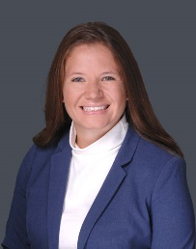
- Brittany Morrissette
Brittany is an assurance manager at RSM US LLP with more than 7 years of experience in the public accounting industry, primarily focused in the financial services sector. Brittany focuses on asset managers, including hedge funds, fund of funds, collective investment trusts, mutual funds and SEC registered commodity pools. Brittany is responsible for serving clients, developing talent, and managing multiple assurance engagements.
Brittany holds an active role in the operational aspects for the firm and spends significant time training and onboarding new professionals. She is also a member of STAR Women’s Network Group. Brittany received her BA in Accountancy from University of Illinois-Champaign, where she was a member of the Business Honors Program, and is a licensed certified public accountant.

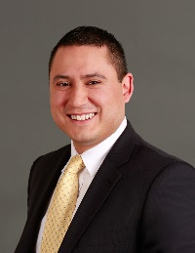
- Alejo Torres (Co-Chair, Marketing)
Alejo is the Principal and Founder at 120s Public Relations where he pairs his expertise with his passion for mission-based projects and causes. Prior to consulting, Alejo spent a year at SevenDesign in California serving as a senior account executive for Visa; and 12 years at the Federal Reserve Bank of Chicago. During that span, Alejo earned national and international recognition as a leading voice and advocate in financial education. While in these roles, he developed highly structured programming, national marketing and promotional campaigns and a diverse network of educators, financial services providers, nonprofits, journalists and government agencies around the globe.
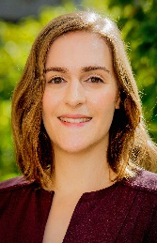
- Celine Kosian
Celine Kosian is a Senior Associate, Strategy at KPMG US, primarily focused on strategy, due diligence and integration projects related to mergers and acquisitions. Prior to joining KPMG in 2018, Celine held various roles in the Strategy and Legal departments at Constellation Brands Inc., a global producer of beer, wine and spirits. Celine has an MBA from the University of Chicago Booth School of Business and BA in History from the University of Pennsylvania.

