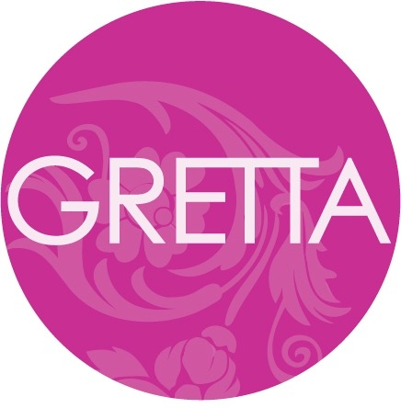

GRETTA’S GOT IT: SELF-MADE STYLE MAVEN
POISED TO BRING THE BEST OF FASHION, SPAS, AND STYLE TO WOMEN EVERYWHERE

You could call hers a Cinderella story—if Cinderella traded in her tiara for a pair of Diors, three spas and a clothing boutique. Gretta Monahan, a self-made style maven, is harnessing the fashion world by its stilettos and reinventing the concept of style. Covering top runway events and appearing as a regular Buddy on the Emmy Award winning Rachael Ray Show for nine seasons, Gretta offers her fashion and beauty know-how to everyone from Hollywood superstars to the mom next door.

Gretta’s award winning collection of sleek boutiques and spa emporiums stretches from Boston to Connecticut, while her frequent television appearances on The Rachael Ray Show and Good Morning America bring her down-to-earth and friendly approach into the homes of fashion-hungry viewers across the country. With the launch of her book, Style and The Successful Girl (October 2013, Gotham Books, Hardcover & Ebook) and upcoming TLC show, Gretta’s expertise is now available to the masses.

GRETTA GETS FASHION: Gretta Luxe and Gretta Style
One of the country’s most trusted fashion experts, Gretta jets off to Milan, New York City, and Paris every season to attend shows and visit designers in their ateliers, hand picking the items offered in her clothing boutique, Gretta Luxe. The Wellesley-based boutique showcases the hottest trends from top designers like Balenciaga, Chloe, and Zac Posen. Each client receives personalized guidance from in-house stylists who assist with picking out the perfect frock or stems. “Every customer gets a celebrity experience from a highly skilled expert,” says Gretta.

GRETTA GETS IT: TV, BOOKS AND MORE…
Appearing regularly on The Rachael Ray Show, Good Morning America and more, Gretta has done over one thousand makeovers and continues to decode hot, new fashion trends each season. She also served as a “fashion accomplice,” co-hosting the second season of Bravo’s Tim Gunn’s Guide to Style. In her weekly column for the Boston Herald, Gretta answers reader inquiries and offers fashion and beauty tips.

Style and the Successful Girl details Gretta’s winning approach to fashion and beauty. This full-color fashion book, packed with stories, sidebars, and photos, aims to help every reader discover and create their own style vision. In 2015, she’ll also be helping brides achieve their dream wedding in her upcoming show on TLC.

GRETTA GETS BEAUTY: Grettacole, G Spa, and beyond
Gretta opened her first Grettacole Salon and Day Spa in Wellesley in 1994. This head-to-toe high-end spa was followed by an outpost in downtown Boston’s Copley Place in 2001. Gretta and her team of highly trained experts focus on listening to clients and advising them on how to meet their needs. “It’s less about the beauty and more about the care, and teaching people,” she says.

In 2008, Gretta opened G-Spa, a sparkling 21,000 square foot oasis at The Fox Tower at Foxwoods Resort Casino. It quickly became a success, receiving Connecticut Magazine’s esteemed, “Best of Connecticut” award. Catering to women (and men) on the go, G Spa offers mini treatments with full VIP services in a sleek, chic setting. The stunning facility provides guests with a full menu of massage, hair, and body treatments, several of which were inspired by Native American traditions and rituals incorporating ingredients like red clay, maize, and mountain laurel. Catherine Zeta-Jones, Pamela Anderson and Gloria Estefan are huge fans.

GRETTA GETS BUSINESS
Raised by her grandmother and aunt in Boston, Gretta attended New York’s Fashion Institute of Technology and trained to become a hair stylist before leaving to sate her entrepreneurial spirit. She opened her first salon at the age of 24, and within 10 years, the sales of her multi-faceted beauty and fashion empire topped $10 million.

A graduate of Harvard Business School’s three-year Owners and Presidents Management Program, Gretta was later selected as a case study subject for the school at only 34 years old. Gretta’s business acuity led her to be a finalist in Ernst & Young’s Entrepreneur of the Year contest.

In addition to her salons, spas, and designer clothing boutiques, Gretta is involved with community outreach and fundraisers for The Crohn's & Colitis Foundation of NYC and the The Ronald S. Lauder Foundation. She splits her time between Boston, Los Angeles and New York City. For more information, visit www.grettastyle.com.

For more information, please contact The Brooks Group at (212) 768-0860.

###

